BILL NO. | SB 689 | SB 827
ACTION VOTED ON | Do pass | Do pass and re-refer to the Committee on Judiciary
 | Aye : No | Aye : No | Aye : No | Aye : No
Gonzalez, Chair | X : | X :
Niello, V. Chair | : X | X :
Allen | X : | X :
Archuleta | X : | X :
Becker | X : | X :
Blakespear | X : | X :
Cortese | X : | X :
Dahle |  | X :
Dodd | X : | X :
Limón | X : | X :
Newman | X : | X :
Nguyen | : X | X :
Seyarto | : X | X :
Umberg | X : | X :
Wahab | X : | X :
Vacancy
 | Ayes : 11 | Ayes : 15 | Ayes : 0 | Ayes : 0
 | Noes : 3 | Noes : 0 | Noes : 0 | Noes : 0

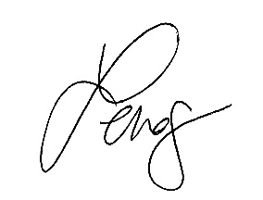
Date of Hearing: 01/09/2024 _______________________________________________, Chair

