BILL NO. | SB 307
ACTION VOTED ON | Do pass and re-refer to the Committee on Appropriations
 | Aye : No | Aye : No | Aye : No | Aye : No
Gonzalez, Chair | X :
Bates, V. Chair
Allen | X :
Archuleta | X :
Becker
Cortese | X :
Dahle | X :
Dodd | X :
McGuire | X :
Melendez
Min | X :
Newman | X :
Rubio
Skinner | X :
Umberg
Wieckowski | X :
Wilk
 | Ayes : 11 | Ayes : 0 | Ayes : 0 | Ayes : 0
 | Noes : 0 | Noes : 0 | Noes : 0 | Noes : 0

Date of Hearing: 01/04/2022 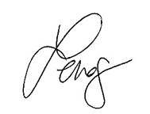, Chair

