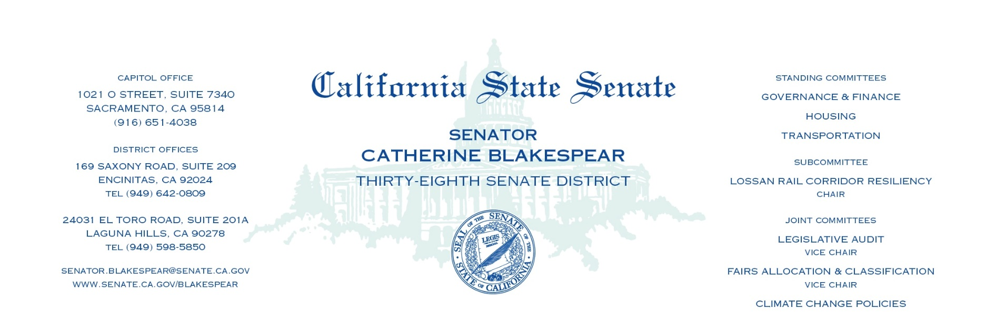

Senate Transportation
Subcommittee on LOSSAN Rail Corridor Resiliency
Informational Hearing

Tracks to Tomorrow: Maximizing the Potential and Safeguarding the Future of the LOSSAN Corridor
August 15, 2023
9:00am 1021 O Street, Room 2200

AGENDA

- Opening Remarks and Review of Last Hearing
Senator Catherine Blakespear
An overview of the takeaways from the hearing of the Subcommittee on May 16, 2023 will be presented.

- Update on Stabilization Work in San Clemente
Supervisor Katrina Foley, Orange County Transportation Authority
Darren Kettle, CEO: Metrolink
Darrell Johnson, CEO: OCTA
An overview of the completed stabilization work on the rail line in San Clemente will be presented in addition to updates on the short and long-term rail planning studies.

- Benefits of the LOSSAN Rail Corridor
Chad Edison, Chief Deputy Secretary for Rail and Transit: CalSTA
Trelynd Bradley, Deputy Director: GO-Biz

State representatives will present the economic, mobility, air quality, goods movement, and national defense benefits of the LOSSAN corridor.

- Future Threats to the LOSSAN Rail Corridor
Dr. Julie Kalansky, Scripps Institution of Oceanography, UC San Diego
Chad Edison, Chief Deputy Secretary for Rail and Transit: CalSTA

An overview of the threats of climate change, sea-level rise, atmospheric rivers, and more on the coast and our rail line will be presented.

- Federal and State Investment
Chad Edison, Chief Deputy Secretary for Rail and Transit: CalSTA
Trelynd Bradley, Deputy Director: GO-Biz
An overview of the various funding sources and investment levels of the LOSSAN Rail
Corridor will be presented.

