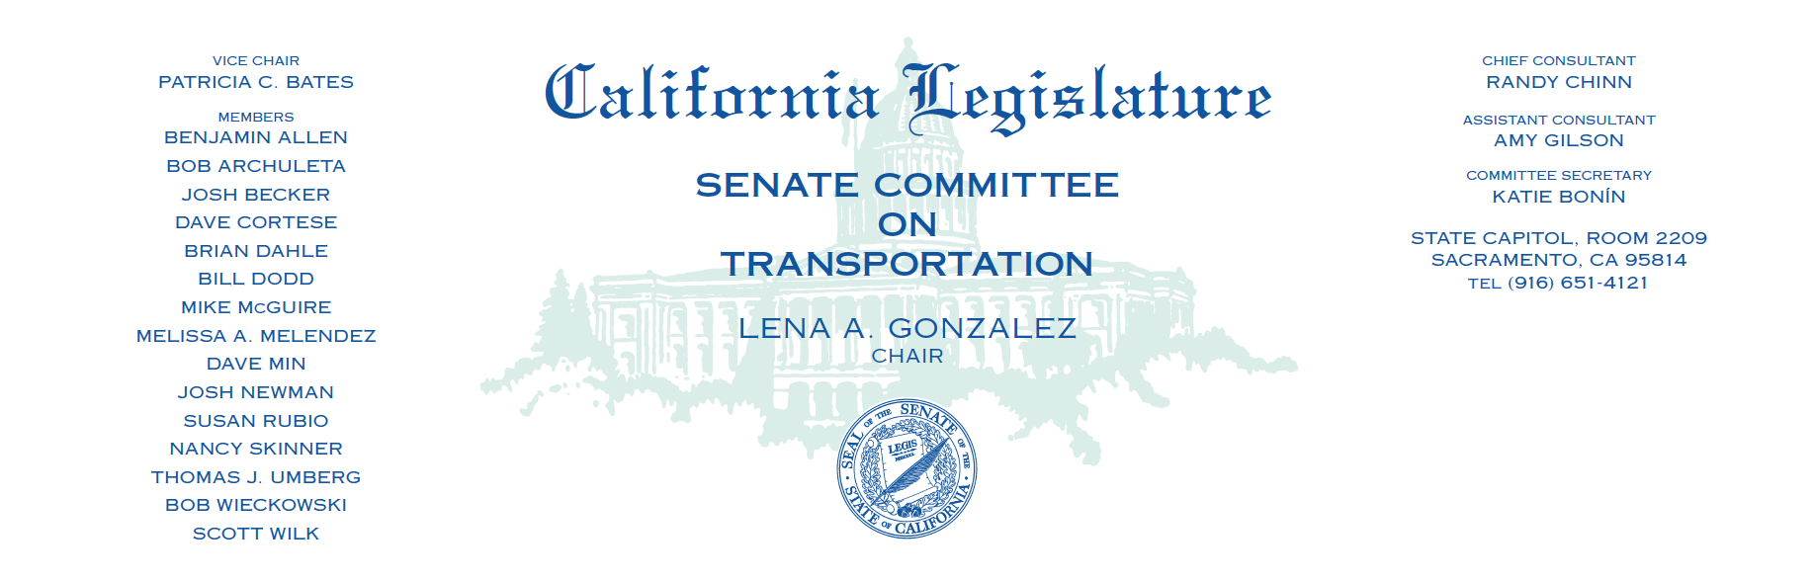
CLEAN TRANSPORTATION HEARING
Tuesday, February 15 2022 at 1:30 pm
Agenda

Welcome and Opening Remarks
- Senator Lena A. Gonzalez, Chair, Senate Transportation Committee

Panel 1: Clean Transportation Technology – Medium- and Heavy-Duty, Off-Road
- Liane M. Randolph, Chair, California Air Resources Board
- Patricia Monahan, Commissioner, California Energy Commission
- Ross Brown, Principal Fiscal and Policy Analyst, Legislative Analyst’s Office
- Wayne Nastri, Executive Officer, South Coast Air Quality Management District
- Joseph Tona, Air Pollution Control Officer, Tehama County Air Pollution Control District

Panel 2: Stakeholders
- Angelo Logan, Policy and Campaign Director, Moving Forward Network
- Heather Tomley, Managing Director of Planning and Environmental Planning, Port of Long Beach
- Patricio Portillo, Senior Advocate, NRDC
- Chris Shimoda, Senior Vice President of Government Affairs, California Trucking Association
- Jessica Durrum, Project Director, Los Angeles Alliance for a New Economy

Panel 3: Industry
- Nicole Rice, President, California Natural Gas Vehicle Coalition
- Teresa Cooke, Executive Director, California Hydrogen Coalition
- Eileen Wenger Tutt, Executive Director, California Electric Transportation Coalition

Public Comment

